Comparison of COVID-19 Survey 2020

Total responses:
- May – 1144
- June – 70

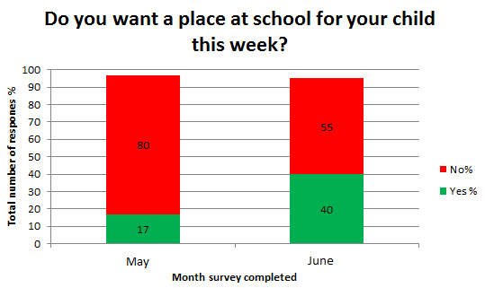
*Total response does not equate to 100% due to some participants not answering this question.

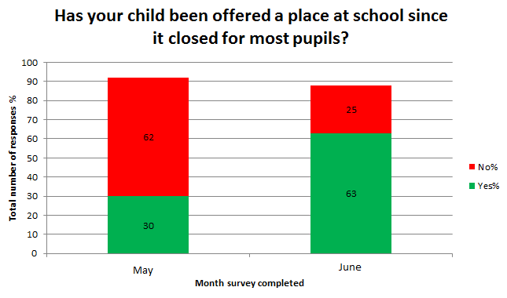
*Total response does not equate to 100% due to some participants not answering this question.

